--------------------------------- NLP NOTES ---------------------------------------

NLP:
Natural processing language is a branch of AI that helps to understand the human’s language either in text or in audio
In this they are two types :
1: NLU( Natural language Understanding )
2: NLG( Natural language Generation )

NLU( Natural language Understanding ):
It involves in the interpretation of the text
Int this they are the 3 key modules are there and they are very useful while using or learning NLP
- BERT : It uses bidirectional attention to understand sentence meaning
- T5 : it treats every task as the text to text which simplifies fine tuning
- GPT : focuses on generating and understanding text in a conversational setting

WORKING OF NLU
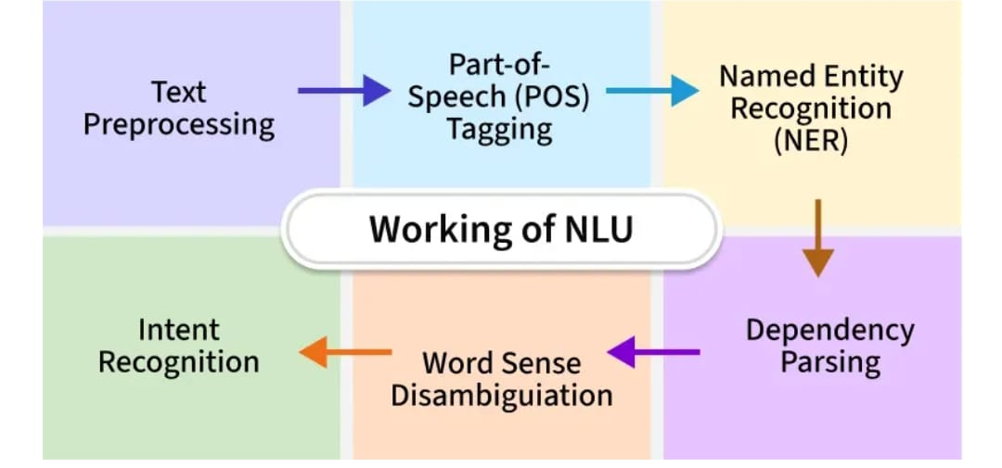

EX: “ A NEW MOBILE IS LAUNCHED IN THE UPCOMING YEAR”
STEP 1:
It simplifies the text and it removes the some texts like “a” ,”the” ,”or”, like that and it removes the non-essential words like it change the word “launched” => “launch” like this simple words it converts in to simple and short form of that word to root
STEP 2:
It identifies that which words belongs to the verb(an action) ,adjectives(a description)
Noun(a thing) like that it separates that words

STEP 3:
Name entity recognition (NER) in this step system identifies the specific informative words like names ,location ,places ,time like that

STEP 4:
The system maps out that how each words are rely to each other to make it sense
In the simple words that it shows the relationship between the words

STEP 5:
It fixes the confusing words to make sense accurately because one word interpreted with so many meanings of that same word in simple words that the words are understood accurately based on how they are using to make it sentence

STEP 6:
The system determines that the purpose or goal behind that input text what ever the user given

STEP 7:
After fully understanding the sentence then the system forms an appropriate answer or action in the simple words a meaningful response is produced to keep the interaction going smoothly.

------------------ THIS IS THE PROCESS HAPPEN IN NLU----------------------

